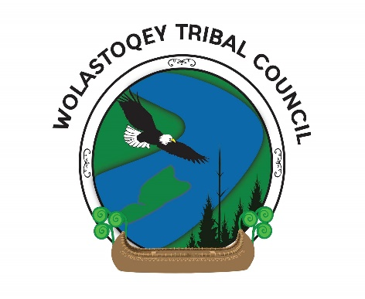
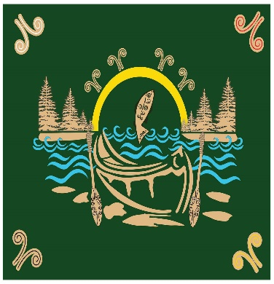
Wolastoqey Kinapuwine
(Let’s be Brave Together)
Delta Fredericton Hotel-Ballroom ABC
Tuesday, March 26, 2019

8:00 a.m. - 9:00 a.m. - Breakfast and Registration
9:00 a.m. – 9:15 a.m. -Traditional Welcome
Elder Victor Atwin, Kingsclear First Nation
9:15 a.m. – 9:30 a.m. – Opening Remarks- Lisa Dutcher-Perley
9:30 a.m. – 9:50 a.m. - Presentation by Wolastoqey Tribal Council-
WTCI Senior Advisor: Megan Fullarton
9:50 a.m. – 10:10 a.m. – Presentation by Wolastoqey Nation in New Brunswick –
WNNB Interim Consultation Director & Governance/ Legal Advisor
10:10 a.m. – 10:50 a.m. – Q&A
10:50 a.m. – 11:05 a.m. - Break
11:05 a.m. – 12: 00 p.m. – Facilitated Community Feedback Session
(Fill out a survey for Communication Strategy)
12:00 a.m. – 1:00 p.m. – Lunch
*Special Performance by “Sisters of the Drum”
1:00 p.m. – 2:00 p.m. -“We Matter: Supporting Indigenous Youth through Hope, Culture & Strength” Keynote Speaker: Tunchai Redvers
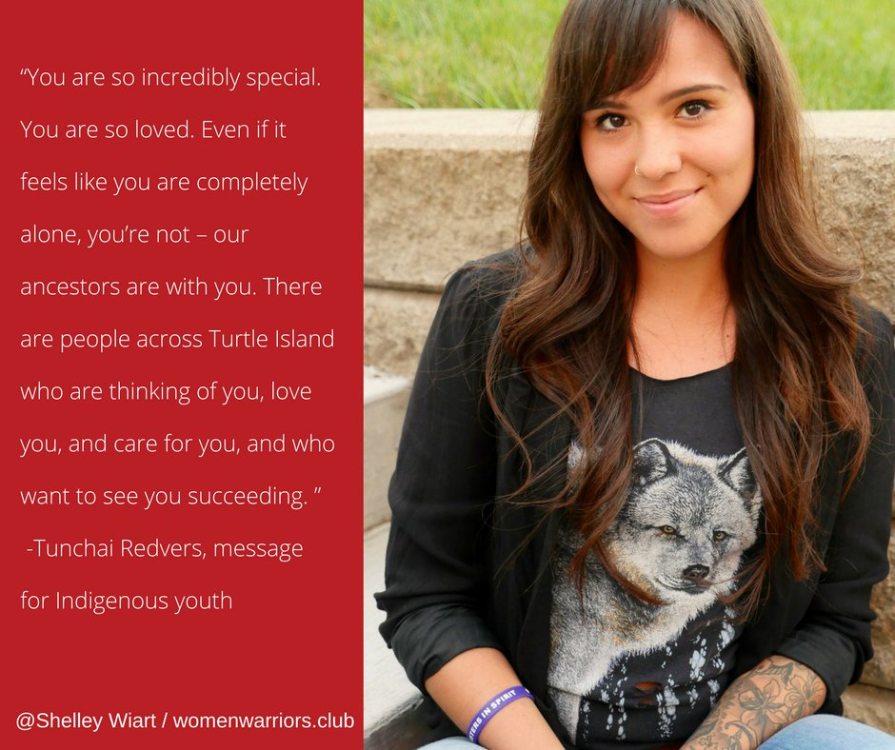
Tunchai Redvers is a Dene/Metis two-spirit social justice warrior, writer, and wanderer from Treaty 8 territory, Northwest Territories and currently living in Toronto. By the age of 24 she has been named on of MTV and We Day’s Top 10 Drivers of Change in Canada, has been published in a number of works for her poetry and writing, is the recipient of the Lawson Foundation’s Emerging Leaders Award, and is the co-founder of We Matter, a national non-profit organization committed to Indigenous youth hope and life promotion. Her advocacy work focuses on Intergenerational trauma, LGBQT and two-spirit rights, youth empowerment, and the decolonization and indigenization of identity, mental health and healing. She has spent considerable time living, travelling, and working with Indigenous communities internationally and across Canada, and considers herself a nomad just like her ancestors.
2:00 p.m. – 2:15 p.m. – Break
2:15 p.m. -4:00 p.m. – Youth Workshop with Tunchai Redvers
2:15 p.m. – 3:15 p.m. – Chiefs Panel:
Chief Allan Polchies Chief Patricia Bernard
St. Mary’s First Nation Madawaska First Nation
Chief Shelley Sabattis Chief Ross Perley
Oromocto First Nation Tobique First Nation
Chief Tim Paul Chief Gabriel Atwin
Woodstock First Nation Kingsclear First Nation

3:15 p.m. -3:45 p.m. – Recap on the day: What we heard, what we learned, what we want to know more about.
3:45 p.m. – 4:00 p.m. – Closing song/ prayer Elder Maggie Paul, St. Mary’s FN

